SAP Function Specification

Document Information
Document Name: Home Control SAP S4HC FS- P006-PPCA
Version: V14
Author: Meos Xu
Date:2026-01-14

Revision History
Version | Created Date | Updated By | Remarks
V10 | 2025/11/3 | Meos | Initial Version
V11 | 2025/11/7 | Meos | Add some logic
V12 | 2025/12/12 | Meos | Adjust the Update Price field;  Adjust Valid from date logic;  Adjust calculation logic of Open PO.
V13 | 2025/12/24 | Meos | Update Logic  - Open POs need to be stored in the database table.  - Generate a report using the data generated after Open PO updating.  - Add fields.  - Update POs and make changes based on the data captured at the time when the info records are updated.
V14 | 2026/1/14 | Meos | Format and convert the FS to a Word version

Business Background
In the current SAP S/4HANA Public Cloud system, standard transactions are available for creating and changing Purchasing Info Records (PIR). However, SAP standard does not provide a pre-posting approval mechanism to control PIR creation or price changes before data is written into master data.
Purchasing Info Records directly impact procurement prices, sourcing decisions, material status, and open Purchase Orders. Uncontrolled changes may lead to financial risk, audit findings, and operational inconsistencies.
To address this gap, a custom approval-driven solution is required. Because approval must be completed before PIR data is posted, standard SAP transactions cannot be used directly. Instead, PIR data must be:
- Collected via predefined upload templates
- Validated and reviewed
- Approved through a configurable approval matrix
- Executed in SAP only after approval
Since the approval process itself is fully custom-developed, batch PIR creation and batch PIR price changes must be developed together as part of one integrated solution. This ensures that all PIR-related changes follow the same governance, approval, and audit logic.

Business Objective

Purchasing Info Record Upload, Approval, Creation and Change
The primary objective is to implement controlled batch upload, approval, creation, and change of Purchasing Info Records in SAP via file upload.
Upload Scenarios
The solution supports the following scenarios:
- Creation of new Purchasing Info Records
- Price change of existing Purchasing Info Records
All uploaded data must pass validation and approval before being posted to SAP master data.
Approval Matrix
An approval matrix is required to control PIR price-related activities:
- One-step approval for PIR creation
- One-step approval for price decrease scenarios
- Two-step approval for price increase scenarios
Approval steps are dynamically determined based on price direction to ensure proper authorization and cost governance.

Product Status Control During PIR Creation
The solution ensures controlled product status management when PIRs are created:
- Product status must be checked before PIR creation
- Only materials with status ZB are allowed for PIR creation
- After successful PIR creation, the material status is updated to ZC
Product status updates are only applied during PIR creation, not during price change.

Open Purchase Order Price Check and Adjustment
When PIR prices are changed, the solution provides controlled processing of open Purchase Orders:
- Fully open PO items: update price directly
- Partially open PO items: split PO item to isolate delivered and undelivered quantities
Open PO processing is manually triggered by the user after PIR update.

Scope

In Scope
The following functionalities are included within the scope of this development:
- Upload PIR data using predefined templates
- Validation of uploaded data
- Step-based approval workflow
- Batch PIR creation and price change
- Determination of final PIR valid-from date
- Product status update during PIR creation
- Manual triggering of Open PO processing
- Selection and update of eligible Open PO items

Out of Scope
- Automatic background Open PO processing
- Processing of POs created after PIR updating date and Valid From date.
- Retroactive changes to fully delivered POs
- Product status update during PIR price change
- Approval for objects other than PIR
- External system integration

Related Systems and Modules
SAP System: SAP S/4HANA Public Cloud
SAP Module: MM – Materials Management
- Purchasing Info Record (PIR) creation and change
- Open Purchase Order (PO) processing and price updates
- Product Status Updates
- Source Lists

Page Overview and UI Layout

Overall Page Overview
The PPCA program consists of three main user operation screens, each representing a distinct business phase in the PIR lifecycle:
- PIR Upload Screen
- PIR Review and Processing Screen
- Open Purchase Order Processing Screen
The screens are designed to be used sequentially, but each screen can also be accessed independently based on business needs.
All screens follow a consistent layout design:
- Header area for selection criteria or upload actions
- Main table area for data display and processing
- Action buttons aligned with the business step of the screen

Screen 1 – PIR Upload Screen

Purpose
The PIR Upload Screen is used to upload PIR-related data using predefined Excel templates.
It serves as the entry point of the PPCA process.
This screen supports:
- PIR creation requests
- PIR price change requests

Layout Description
The screen is divided into the following areas:
Header Area
- Upload Scenario Selection (Create PIR / Change PIR Price)
- File Upload control
- Template Download button
Action Area
- Upload button
- Test Run button
Result Area
- Upload log
- Validation result messages

Key Fields and Controls
Header and Action Area
Field / Control | Description
Business Type | Determines whether the uploaded file is treated as Add Price or Change Price
Upload Button | Uploads the file
Download For Template | Downloads the template
Download Button | Downloads the data uploaded
Trigger Button | Test run: uploads and triggers data validation logic  Post: Posts to approval
Result Area
Field / Control | Description | Comments
Remark | Free-text field for additional comments or internal notes related to the PIR creation request. | Mandatory for Material Type: ZFER, will be fill into Long-text of info record
Condition Type | Price condition type to be maintained in the Purchasing Info Record. | Mandatory, Default value: PPR0
Purchase Org | Purchasing organization under which the Purchasing Info Record will be created. | Mandatory, Default value: R001
Purchase Group | Purchasing group responsible for the Purchasing Info Record. | Mandatory，will be fill into“Supplier Material/Product group”
Plant | Plant to which the Purchasing Info Record applies. | Mandatory
Material | Material number for which the Purchasing Info Record is created. | Mandatory
Info Category | Category of the Purchasing Info Record defining the procurement scenario. | Mandatory
Vendor | Vendor for whom the Purchasing Info Record is created. | Mandatory
Price | Unit price to be maintained in the Purchasing Info Record. | Mandatory
Unit | Currency in which the price is maintained. | Mandatory, currency
Per | Quantity to which the price refers. | Mandatory, Default :1000
UoM | Unit of measure corresponding to the price quantity. | Mandatory, Unit of measure
Valid From | Start date from which the Purchasing Info Record becomes valid. | Mandatory, Date format: YYYYMMDD
Valid To | End date of validity for the Purchasing Info Record. | Mandatory, Date format: YYYYMMDD
Source List FLAG | Indicator specifying whether the vendor should be maintained in the source list. | If want to maintain Source list, Set X
Quotation Attachment | Vendor quotation document supporting the PIR creation. | Mandatory, Not need for Post to info record
Benchmark Quotation Attachment | Benchmark or reference quotation used for price comparison. | Not need for Post to info record
Justification | Business justification explaining the reason for creating the Purchasing Info Record. | Mandatory when Benchmark Quotation Attachment is empty
Status | Status for PPCA
Error Log | Error log when uploading
ID Document | PPCA ID | will be fill into Long-text of info record

Processing Rules
- Uploaded files must strictly follow the predefined template structure
- No SAP master data is updated at this stage
- Successfully uploaded data is stored in staging tables and awaits review

Screen 2 – PIR Review and Processing Screen

Purpose
The PIR Review and Processing Screen is the core control screen of the PPCA program.
It is used for:
- Reviewing uploaded PIR data
- Submitting requests for approval
- Performing approval actions
- Executing PIR creation or price changes after approval
- Generate PO

Layout Description
The screen consists of:
Selection Area
- Request ID
- Upload date range
- Status
- PIR Scenario
Main Table Area
- Displays uploaded PIR records with status and key attributes
Action Button Area
- Submit for Approval
- Approve / Reject
- Run
- Repost
- Generate Open PO

Key Fields (Main Table)
Field | Description
ID | Internal ID
Type | Type：  001-Add Price  002-Update Price
Approval ID | PPCA ID
Remark | Free-text field for additional comments or internal notes related to the PIR creation request.
Info Record Number | Info Record Number need to change
ConditionType | Price condition type to be maintained in the Purchasing Info Record.
PurchaseOrg | Purchasing organization under which the Purchasing Info Record will be created.
PurchaseGroup | Purchasing group responsible for the Purchasing Info Record.
Plant | Plant to which the Purchasing Info Record applies.
Material | Material number for which the Purchasing Info Record is created.
InfoCategory | Category of the Purchasing Info Record defining the procurement scenario.
Vendor | Vendor for whom the Purchasing Info Record is created.
Amount | Unit price to be maintained in the Purchasing Info Record.
Unit | Currency in which the price is maintained.
Per | Quantity to which the price refers.
UoM | Unit of measure corresponding to the price quantity.
Valid From | Start date from which the Purchasing Info Record becomes valid.
Valid To | End date of validity for the Purchasing Info Record.
Source List FLAG | Indicator specifying whether the vendor should be maintained in the source list.
Quotation Attachment | Vendor quotation document supporting the PIR creation.
Benchmark Quotation Attachment | Benchmark or reference quotation used for price comparison.
Justification | Business justification explaining the reason for creating the Purchasing Info Record.
Requester | Requester
Approval status | Status for Approval
Line Manager | Line Manager
Manager | Manager
Approved Date | Approved Date
Info Record Number | Generated Info Record Number
Source List Number | Generated Source List Number
Product Status | Changed Product Status
Info Record Number Interface Status | Interface Status
Source List Number Interface Status | Interface Status
Product Status Interface Status | Interface Status
Info Record Number Interface Log | Error log
Source List Number Interface Log | Error log
Product Status Interface Log | Error log
Open PO Status | Generating Open PO status
Open PO Log | Log

Approval and Execution Controls
- Approval buttons are enabled only for assigned approvers
- Execute PIR Update button is enabled only when:
  - Approval status = Approved
  - Execution status = Not Executed

SAP Screen
Info Record
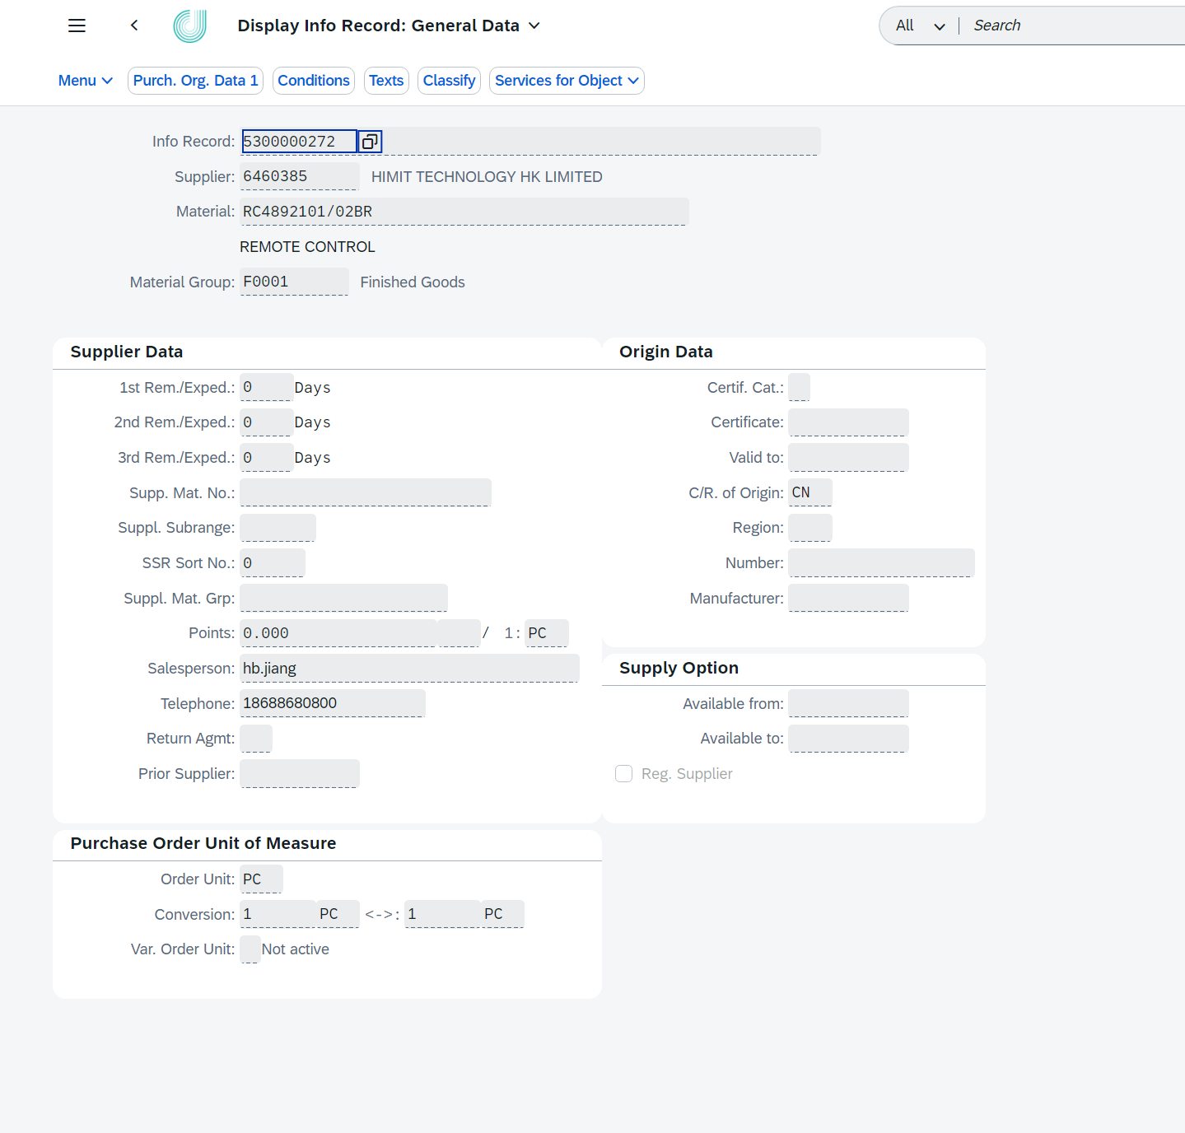
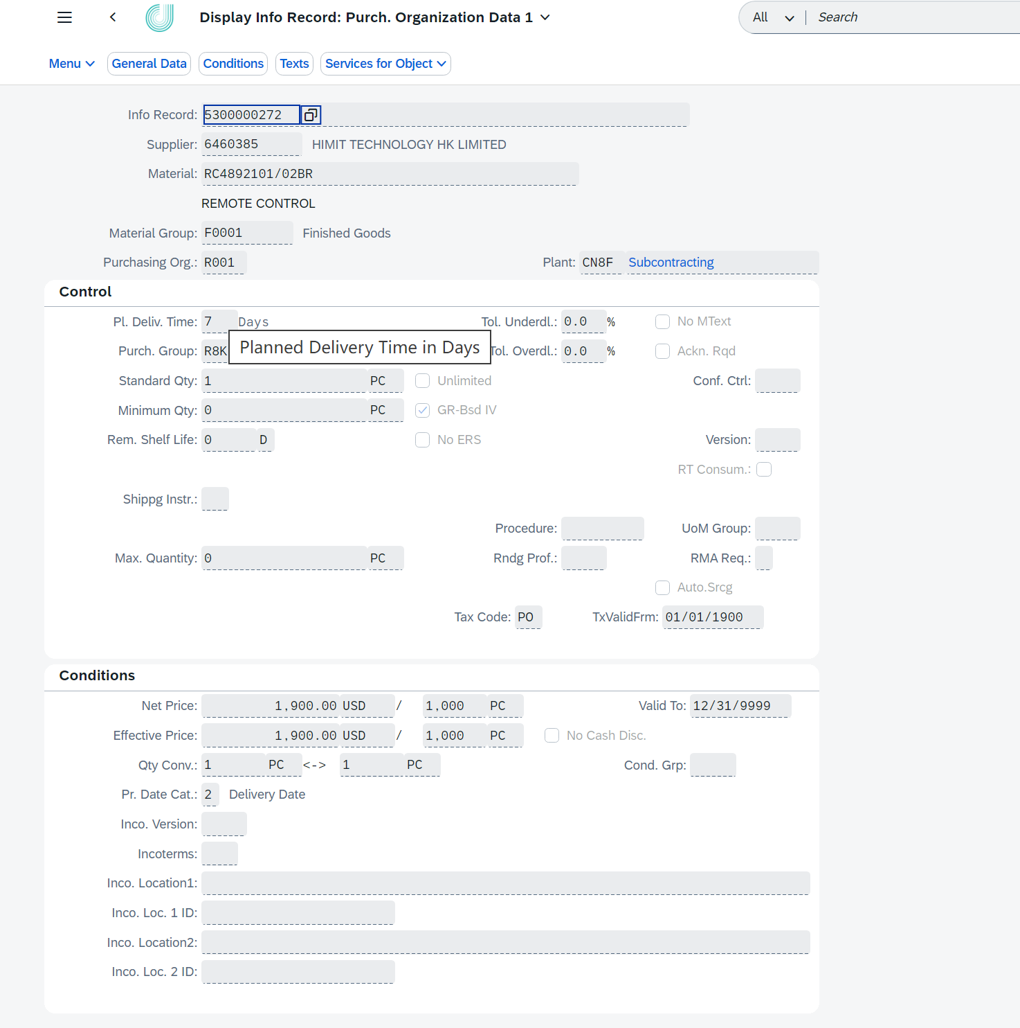
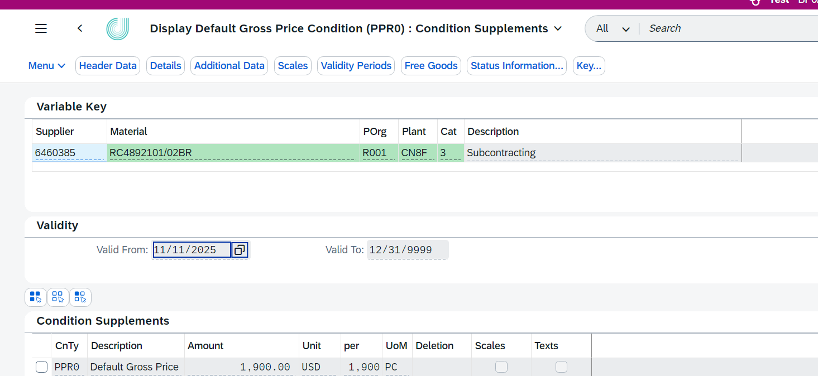
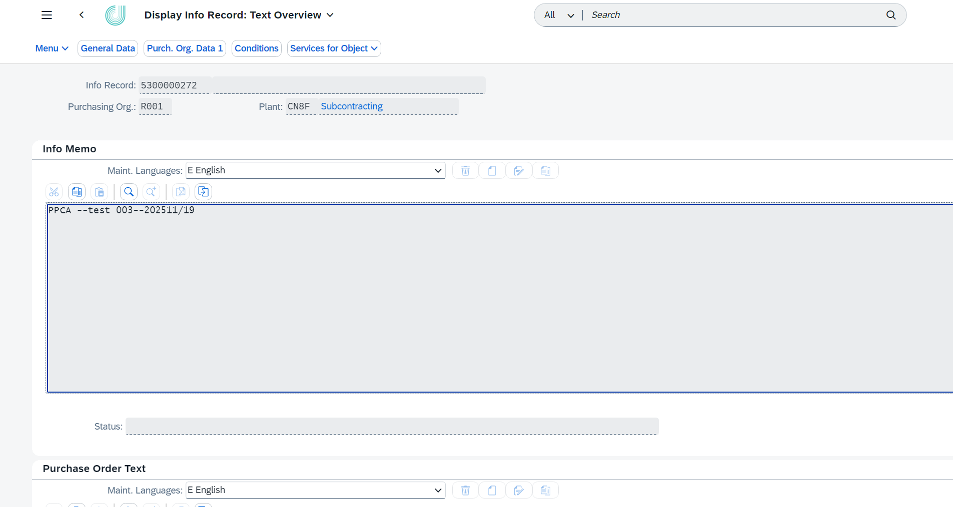
Source List
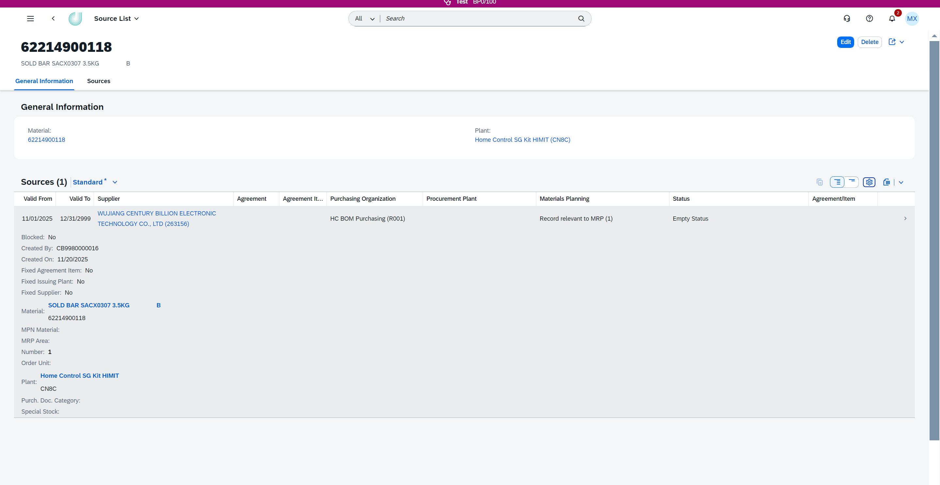

Screen 3 – Open Purchase Order Processing Screen

Purpose
The Open Purchase Order Processing Screen is used to:
- Identify Open Purchase Orders affected by PIR price changes
- Allow user-controlled update of Open PO prices
This screen is manually triggered and is not automatically executed after PIR update.

Layout Description
The screen includes:
Selection Area
- Request ID
- Material
- Vendor
- Plant
Action Area
- Generate Open PO button
- Execute PO Update button
Main Table Area
- Displays eligible Open PO items

Key Fields (Open PO Table)
Table Level | Field | Description
Parent | Info Record | Purchasing Info Record number updated
Parent | PPCA Approval ID | PPCA approval request ID
Parent | PO Date | Purchase Order document date
Parent | PO Number | Purchase Order number
Parent | PO Item | Purchase Order item number
Parent | Supplier | Supplier number
Parent | Material | Material number
Parent | Plant | Plant number
Parent | PO Quantity | Original ordered quantity of the PO item
Parent | Delivered Quantity | Quantity already delivered for the PO item
Parent | Order Unit | Order unit of measure
Parent | PO Net Price | Current net price of the PO item
Parent | Currency | Currency key of the PO price
Parent | Price Unit | Price unit maintained on the PO
Parent | Order Price UoM | Order Price UoM
Parent | Info Record Net Price | Net price from the approved Purchasing Info Record
Parent | Skip PO Price Change | If checked, the PO price will not be updated.
Parent | Open Quantity | Default open quantity calculated during Open PO generation (PO item quantity - delivered quantity). Read-only field
Parent | Change Status | Processing status of the PO update

Table Level | Field | Description
Child | PO Number | Updated Purchase Order number
Child | PO Item | Updated Purchase Order item number
Child | PO Quantity | Updated quantity after PO processing
Child | Order Unit | Order unit of measure
Child | PO Net Price | Updated net price applied to the PO item
Child | Currency | Currency key
Child | Price Unit | Price unit
Child | Order Price UoM | Order Price UoM
Child | PPCA ID | PPCA approval ID linked to the PO update record and need to fill in PO item

Processing Rules
- Open PO scope is fixed at the time of clicking “Generate Open PO”
- Only selected (non-skipped) PO items are updated
- Updates are logged for audit and traceability by SAP standard function.
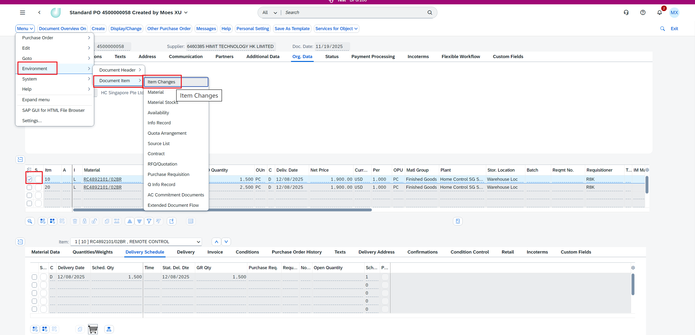

Custom Tables
The following custom tables are used to support business processing within the program:
- Tax Code Table – used for tax code determination and validation during PIR processing
- Approval Matrix Table – used to control the approval steps and approval routing for PIR creation and changes
- Info Record and Info Record Description Table – used to compare Purchasing Info Records and support Open Purchase Order determination logic

Navigation and Control Principles
- Screens are function-based and authorization-controlled by approval matrix.
- No background or automatic processing is triggered without explicit user action

Upload Template Description

Upload Template for PIR Creation

Purpose
The PIR Creation Upload Template is used to support batch creation of new Purchasing Info Records (PIR) through file upload.
Each row in the template represents one independent PIR creation request and will be processed through validation and approval before the PIR is created in SAP.
This template is applicable only when no Purchasing Info Record exists for the given Material, Vendor, Plant, and purchasing attributes.

Supported Scenario
- Creation of new Purchasing Info Record (PIR)

Field Description
Field Name | Description | Comments
Remark | Free-text field for additional comments or internal notes related to the PIR creation request. | Mandatory for Material Type: ZFER
Condition Type | Price condition type to be maintained in the Purchasing Info Record. | Mandatory, Default value: PPR0
Purchase Org | Purchasing organization under which the Purchasing Info Record will be created. | Mandatory, Default value: R001
Purchase Group | Purchasing group responsible for the Purchasing Info Record. | Mandatory
Plant | Plant to which the Purchasing Info Record applies. | Mandatory
Material | Material number for which the Purchasing Info Record is created. | Mandatory
Info Category | Category of the Purchasing Info Record defining the procurement scenario. | Mandatory
Vendor | Vendor for whom the Purchasing Info Record is created. | Mandatory
Price | Unit price to be maintained in the Purchasing Info Record. | Mandatory
Unit | Currency in which the price is maintained. | Mandatory, currency
Per | Quantity to which the price refers. | Mandatory, Default :1000
UoM | Unit of measure corresponding to the price quantity. | Mandatory, Unit of measure
Valid From | Start date from which the Purchasing Info Record becomes valid. | Mandatory, Date format: YYYYMMDD
Valid To | End date of validity for the Purchasing Info Record. | Mandatory, Date format: YYYYMMDD
Source List FLAG | Indicator specifying whether the vendor should be maintained in the source list. | If want to maintain Source list, Set X
Quotation Attachment | Vendor quotation document supporting the PIR creation. | Mandatory, Not need for Post to info record
Benchmark Quotation Attachment | Benchmark or reference quotation used for price comparison. | Not need for Post to info record
Justification | Business justification explaining the reason for creating the Purchasing Info Record. | Mandatory when Benchmark Quotation Attachment is empty

General Rules
- The predefined PIR Creation Upload Template must be used without structural changes
- Mandatory fields must be filled according to business rules
- Each PIR creation request is subject to approval before execution

Upload Template for PIR Price Change

Purpose
The PIR Price Change Upload Template is used to submit price adjustment requests for existing Purchasing Info Records through file upload.
Each row in the template represents one independent PIR price change request and will be processed through validation and approval before being applied in SAP.
This template does not support PIR creation.

Supported Scenario
- Price change of existing Purchasing Info Record

Field Description
Field Name | Description | Comments
Remark | Free-text field for additional comments related to the price change request. | Mandatory for Material Type: ZFER
Condition Type | Price condition type to be changed in the Purchasing Info Record. | Mandatory, Default value: PPR0
Info Record | Identifier of the existing Purchasing Info Record to be updated. | Mandatory, Default value: R001
Purchase Org | Purchasing organization under which the Purchasing Info Record exists. | Mandatory
Plant | Plant associated with the Purchasing Info Record. | Mandatory
Material | Material number of the existing Purchasing Info Record. | Mandatory
Info Category | Category of the Purchasing Info Record to be updated. | Mandatory
Vendor | Vendor of the existing Purchasing Info Record. | Mandatory
Amount | New price amount to be applied to the Purchasing Info Record. | Mandatory
Unit | Currency of the new price. | Mandatory, currency
Per | Quantity to which the new price refers. | Mandatory, Default :1000
UoM | Unit of measure corresponding to the price quantity. | Mandatory, Unit of measure
Valid From | Start date of the new price validity. | Mandatory, Date format: YYYYMMDD
Valid To | End date of validity for the new price. | Mandatory, Date format: YYYYMMDD
Quotation Attachment | Supporting attachment for the price change request. | Mandatory, Not need for Post to info record
Justification | Business justification explaining the reason for the price change. | Mandatory when Benchmark Quotation Attachment is empty

General Rules
- The corresponding Purchasing Info Record must already exist in SAP
- The template is used only for PIR price change scenarios
- All price change requests require approval before being applied

Business Process Flow

Triggering Event
The PPCA (Purchasing Price Change Authorization) process is triggered when a business user uploads a predefined Purchasing Info Record (PIR) Excel template and submits the data for processing.
The triggering event occurs in the following scenarios:
- Upload of PIR creation data
- Upload of PIR price change data for an existing PIR
Uploading data itself does not result in any update to SAP master data. All uploaded records must pass validation and approval before execution.

End-to-End Business Process Steps
The end-to-end PPCA business process consists of the following steps:
    - Step 1 – PIR Data Upload
The requestor uploads the predefined PIR Excel template via the PIR Upload Screen and selects the applicable business scenario (PIR Creation or PIR Price Change).
    - Step 2 – System Validation and Pre-processing
After upload, the system performs backend validation, including:
- Mandatory field validation
- Data format validation (date, numeric fields)
- Material status validation (PIR creation scenario only)
- Tax code determination based on custom tax code table (PIR creation scenario only)
If any validation fails, the system generates detailed error logs and returns them to the requestor. No approval process is triggered at this stage.
    - Step 3 – Manual Submission for Approval
After all records pass validation, the requestor manually clicks “Submit for Approval” to trigger the approval workflow.
The approval process is not triggered automatically after upload to avoid unnecessary approval cycles caused by incomplete or incorrect data.
    - Step 4 – Approval Notification
When the request enters an approval node, the system sends an email notification to the assigned approver.
    - Step 5 – Approval Processing
The approver reviews the request details and performs one of the following actions:
- Approve
- Reject
Approval paths are determined based on:
- PIR scenario (Creation or Price Change)
- Price change direction (Increase or Decrease)
    - Step 6 – Approval Result Notification
After the approval process is completed (final approval or rejection), the system sends an email notification to the requestor with the approval result.
    - Step 7 – Execution Confirmation by Requestor
For approved requests, the requestor confirms execution in the PIR Review & Processing Screen. This confirmation triggers actual master data processing.
    - Step 8 – PIR Creation or Update Execution
The system creates or updates the Purchasing Info Record in SAP based on approved data and defined business logic.
    - Step 9 – Source List Creation (PIR Creation Only)
After successful PIR creation, the system attempts to create the corresponding Source List record for the material, vendor, and plant.
    - Step 10 – Material Status Update (PIR Creation Only)
If both PIR creation and Source List creation are successful, the system updates the material status accordingly.
    - Step 11 – Manual Trigger of Open PO Processing
After PIR update, the user manually clicks “Generate Open PO” to identify applicable open Purchase Orders.
    - Step 12 – Open PO Update and Reporting
The system updates eligible open Purchase Orders based on defined rules and generates results.

Business Decision Points
Key business decision points within the PPCA process include:
- PIR Creation versus PIR Price Change
- Price Increase versus Price Decrease
- Approval versus Rejection
- Totally Open Purchase Order versus Partially Open Purchase Order
- Purchase Order selected for update versus skipped by user

Processing Result
The PPCA process results in:
- Approved Purchasing Info Records posted to SAP
- Controlled material status update (PIR creation only)
- Controlled open Purchase Order price adjustment
- Complete audit trail including approval history, execution records, and Open PO processing results

Business Logic Description
This chapter describes the key business rules and control logic implemented in the PPCA solution.
All logic defined in this chapter is mandatory and must be strictly followed during system execution.

Purchasing Info Record Valid From Date Logic
During PIR creation or PIR price change execution, the system determines the final Valid From date based on the following rule:
Final PIR Valid From Date = the later of:
- The “Valid From” date provided in the uploaded Excel template
- The system execution timestamp when the user clicks “Execute PIR Update”
This logic ensures:
- The PIR does not become effective before the user explicitly confirms execution
- No retroactive application of price or conditions
- Alignment between approval completion time and master data effectiveness
Example1:
- Uploaded Valid From Date: 2026-12-16
- User execution date: 2026-10-17
→ Final Valid From Date: 2026-12-16
Example2:
- Uploaded Valid From Date: 2026-12-01
- User execution date: 2026-12-17
→ Final Valid From Date: 2026-12-17

Material Status Update Logic and Conditions
Material status update applies only to PIR creation scenarios.
Pre-condition Check
Before PIR creation, the system checks the current material status:
- Only materials with status ZB are allowed to proceed with PIR creation
- If the material status is not ZB, the request is rejected during validation
Post-update Logic
After PIR creation execution:
- PIR must be successfully created in SAP
- Source List creation must be successful
Only when both conditions are met, the system updates the material status from ZB to ZC.
Control Principles
- If PIR creation fails → no material status update
- If Source List creation fails → no material status update
- PIR price change scenarios do not trigger any material status update
This design prevents partial updates and ensures data consistency.

Source List Creation Logic
Source List creation is triggered only in PIR creation scenarios.
Creation Conditions
- PIR creation scenario
- PIR successfully created in SAP
- Material, Vendor, and Plant are available in the PIR data
Processing Rules
- The Source List validity period aligns with the PIR validity period
Exception Handling
If Source List creation fails:
- The PIR remains successfully created
- Material status update is not executed
- The failure is logged for follow-up processing

Open Purchase Order Scope Determination Logic
Open Purchase Orders are identified only when the user manually clicks “Generate Open PO”.
Selection Time Point
- The Open PO scope is fixed at the moment of clicking “Generate Open PO”
- Purchase Orders created or changed after this time are not included in the current processing
Selection Conditions
Only PO items meeting all of the following conditions are selected:
- PO item is not deleted
- PO document date is earlier than or equal to the final PIR Valid From date
- Undelivered quantity is greater than zero
Matching Rules
PO items are considered relevant if either of the following rules is met:
- PO Info Record number equals the updated PIR number
AND Plant and Item Category are the same
- PO old Info Record description matches the updated PIR description
(via custom table: Info Record and Info Record Description Table)
AND Plant and Item Category are the same
This dual matching logic ensures coverage of both standard and historical PO scenarios.

Open Purchase Order Update Logic
After Open PO identification, the system processes PO items as follows:
Totally Open Purchase Orders
- The PO item price is updated directly to the approved PIR price
Partially Open Purchase Orders
- Original PO item:
  - Quantity is adjusted to delivered quantity
  - Original price is retained
- New PO item:
  - Quantity equals the remaining undelivered quantity
  - Price is updated to the approved PIR price
User Control
- The system displays all eligible Open PO items to the user
- The user may mark specific PO items to Skip Update
- Marked PO items are excluded from price update processing
Traceability
For updated PO item, the system records:
- PPCA Request ID
- Update date and time

Email Notification Logic
Approval Notification
- When a PIR request enters any approval node, the system sends an email notification to the corresponding approver
Approval Result Notification
- After the approval process is completed (approved or rejected), the system sends an email notification to the requestor
Non-trigger Scenarios
Emails are not sent in the following cases:
- Upload validation fails
- The requestor has not submitted the request for approval

Exception Handling
Scenario | Description | System Behavior
Validation error | Mandatory field missing | Error log returned
Approval rejection | Rejected by approver | Status set to Rejected
PIR update failure | SAP update error | Error recorded
Open PO update failure | PO locked or authorization issue | Error logged

Authorization
Role | Authorization
Requester | Upload, submit, confirm
Approver | Approve / reject

Risk and Impact Analysis

Identified Risks and Mitigation Measures
This section identifies potential business risks related to Purchasing Info Record (PIR) updates and Open Purchase Order (PO) price adjustments, and defines corresponding mitigation and control measures.
No. | Risk Description | Business Impact | Mitigation / Control
1 | Open Purchase Orders created after PIR update execution but before the new PIR price Valid From date will continue to use the old price. | Price inconsistency may occur for Purchase Orders created during the gap period between PIR execution and PIR price effective date. | This behavior follows the PIR Valid From date control logic. Business users should carefully plan the Valid From date and align it with purchasing timelines.
2 | The system retrieves all eligible Open Purchase Orders created before the PIR Valid From date. If users do not explicitly exclude certain PO items, POs that are received after the price update but before the PIR Valid From date may be posted with the new price. | Goods receipt may be posted using the updated price, which may not align with the original commercial agreement. | The Open PO Processing Screen provides manual selection and exclusion capability. Users are responsible for reviewing and excluding PO items that should not be affected.
3 | Open Purchase Order processing is manually triggered and depends on user judgment and timing. | Incorrect trigger timing may lead to unintended price updates. | Manual triggering is intentionally designed to avoid automatic mass updates. Clear business procedures and user training are required.
4 | Partially delivered Purchase Orders require PO item split processing. | PO item split may increase reconciliation and follow-up complexity. | Standard split logic is applied to separate delivered and undelivered quantities, ensuring price traceability and auditability.
5 | Open Purchase Orders are identified based on the system snapshot at the moment the user clicks “Generate Open PO”. Any subsequent changes to the same PO (e.g. quantity change, delivery date change, new PO item creation) will not be considered in the same processing run. | Subsequent PO changes may not be reflected in the price adjustment results, potentially leading to price inconsistency for later business changes. | This behavior is by design to ensure processing consistency and audit traceability. If further PO changes occur, users may re-trigger the Open PO processing or handle adjustments manually according to business procedures.

Business Impact Summary
The PPCA solution introduces strong governance and approval control for Purchasing Info Record maintenance and price changes.
However, due to the nature of effective date control, manual triggering, and Purchase Order lifecycle timing, certain price application behaviors require clear business understanding and disciplined user operation.
Proper definition of PIR Valid From dates, careful review of Open PO selection, and correct trigger timing are essential to minimize price inconsistencies and operational risks.

